DIGITAL
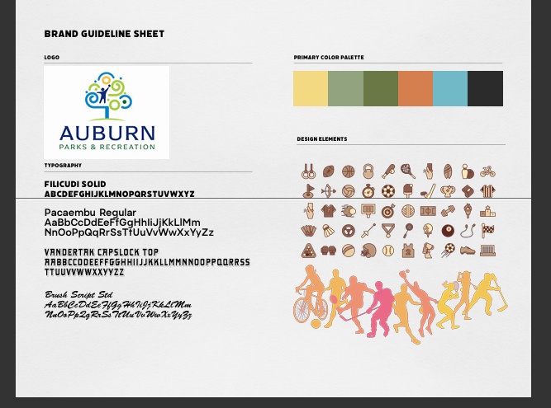
- A branding guideline kit would serve as the central reference for all visual and written communication, ensuring consistency across digital, print, and social media materials. The kit would include a clearly defined color palette, approved fonts, logo usage rules, and design elements that reflect the organization’s identity. It would outline how these elements should appear in sponsorship packets, email campaigns, social media graphics, flyers, thank‑you notes, and community‑facing materials.

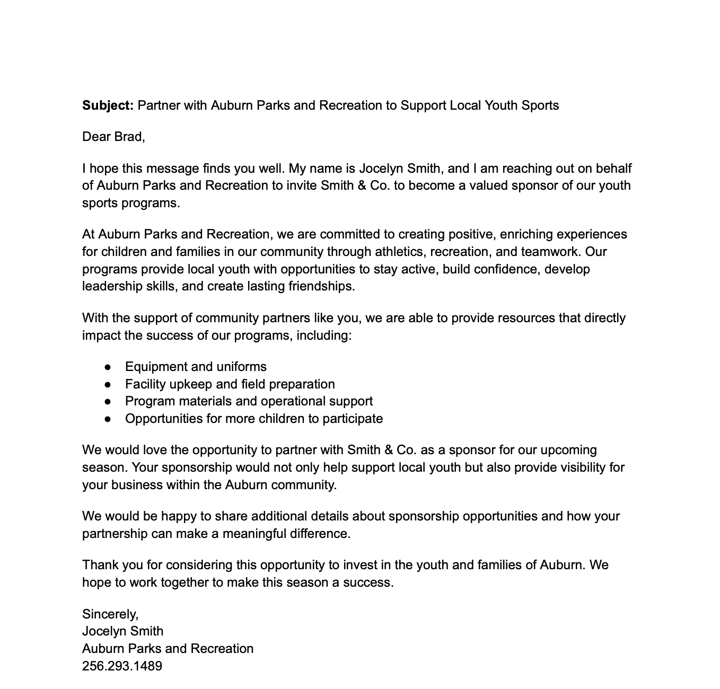
- Copy for an email campaign that includes: (1) an email requesting sponsorship, (2) an email thanking sponsors for

- A mock community-focused Facebook post to share the ways the local community benefits from sponsor support; part of the “Your Sponsorship Dollars at Work” mini-campaign.

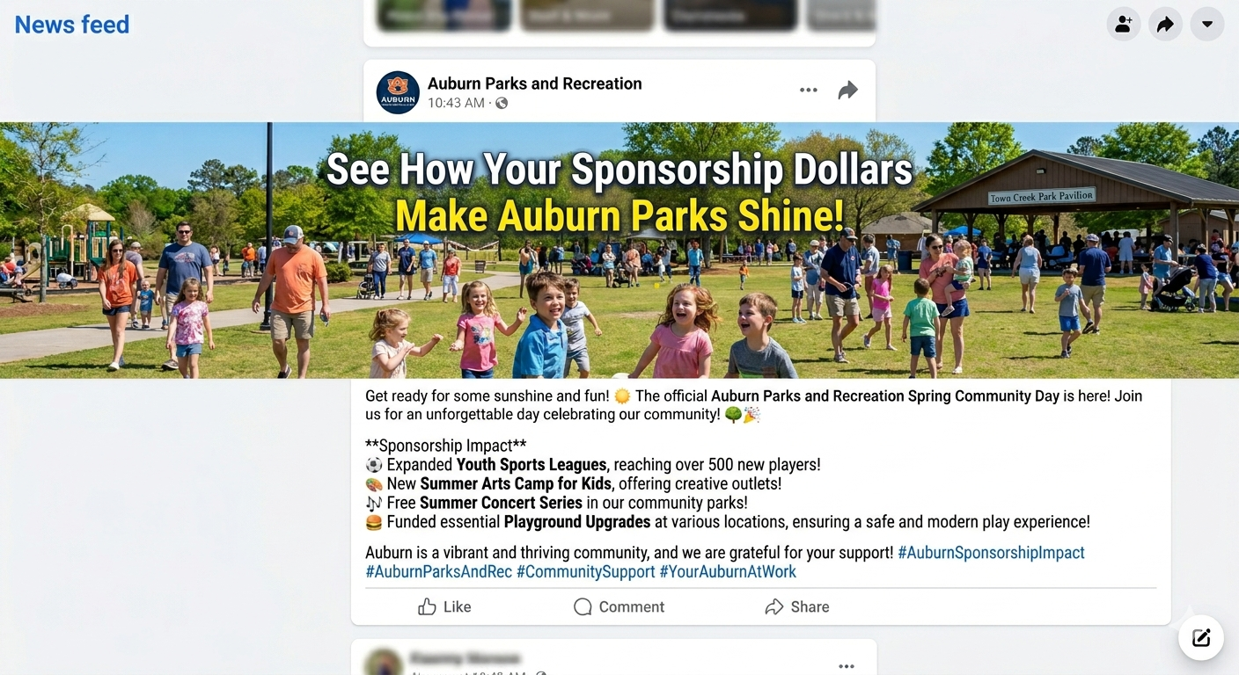
4. A mock community-focused Facebook post that highlights how businesses can benefit from sponsorship while also supporting the community; part of the “Your Sponsorship Dollars at Work” mini-campaign.

5. A mock “Sponsor Shoutout” for Facebook and LinkedIn that highlights a business that has sponsored a team or event during the year
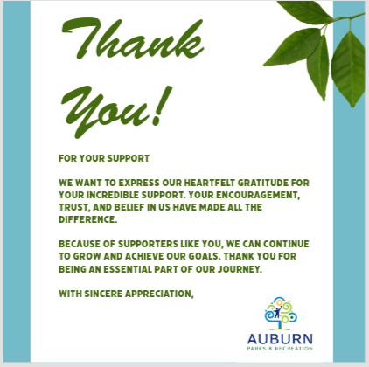
TRADITIONAL
- Printed thank you notes to be mailed to each sponsor after they agree to sponsor a team or event
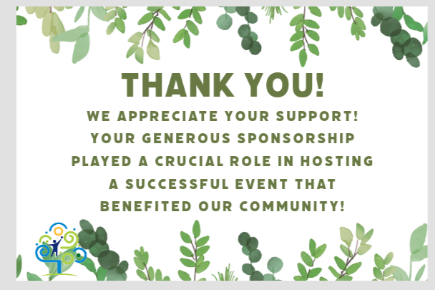
- A brochure that shares multiple success stories from teams or events that were funded by sponsorship that will be mailed to sponsors; part of the “Your Sponsorship Dollars at Work” mini-campaign
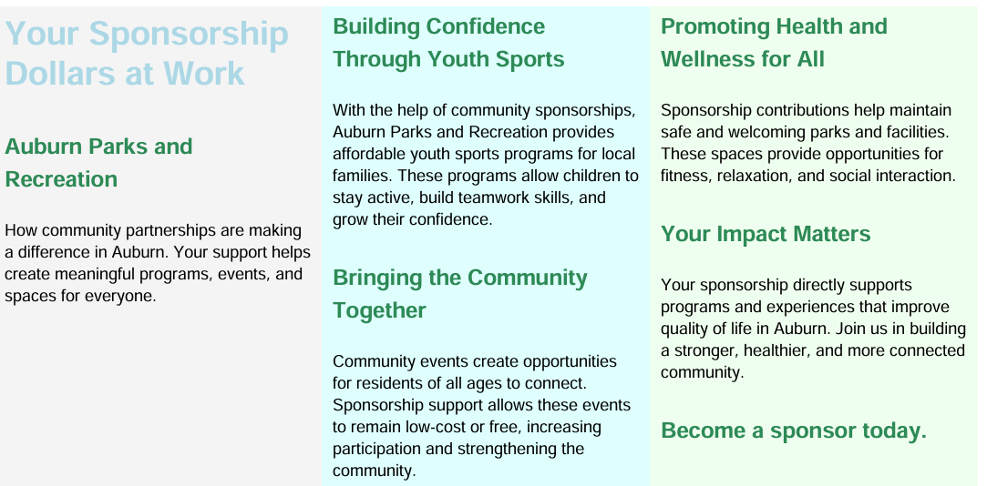
- A redesigned print sponsorship-packet that utilizes Auburn Parks and Recreation branding
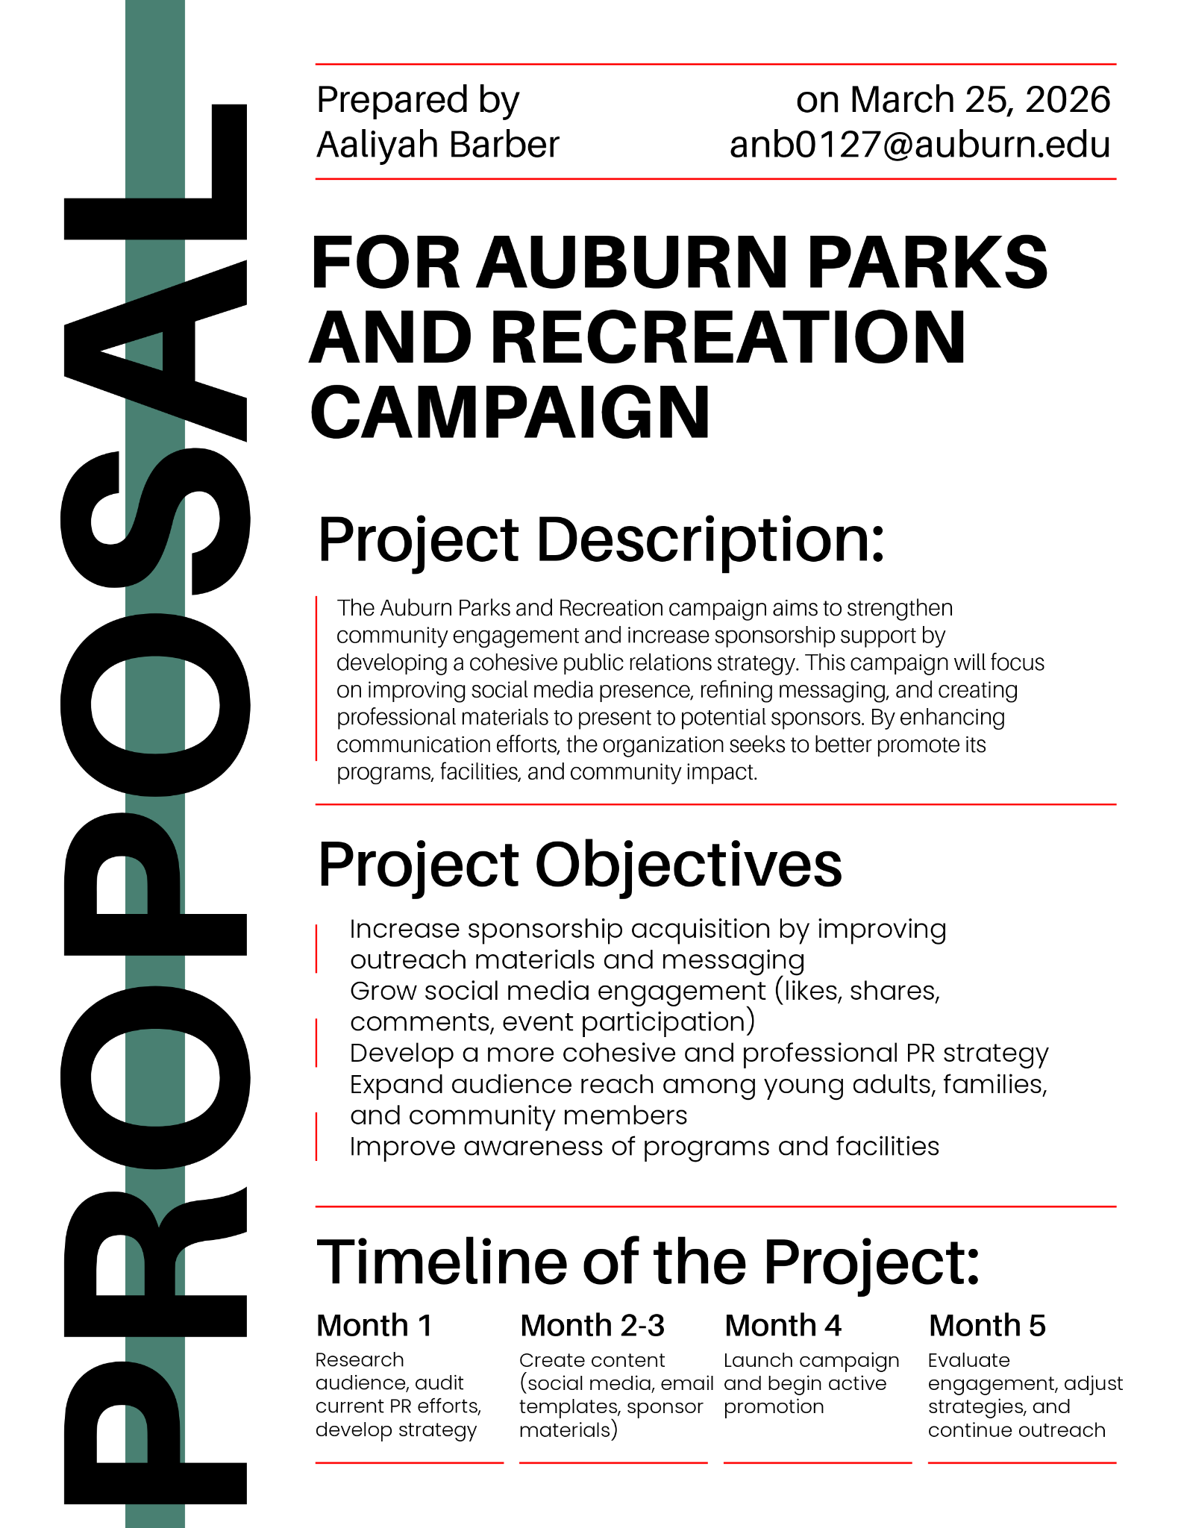
- A package of free food tickets for Auburn CityFest and SummerNight Downtown Art Walk, encouraging sponsors to get involved with the community and showing gratitude for their support
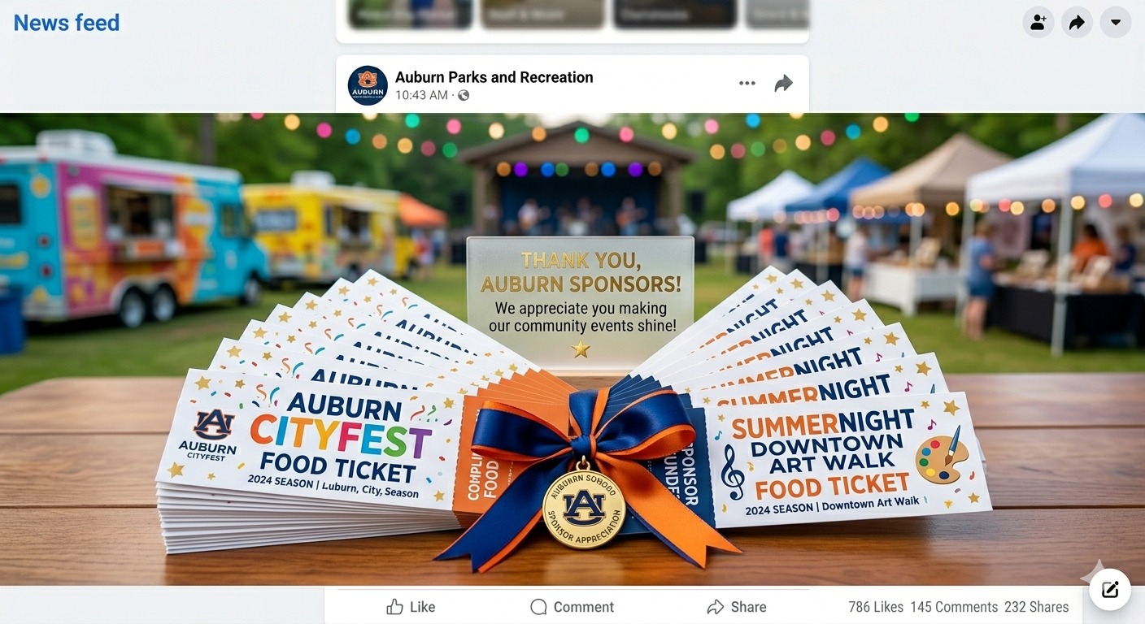

We believe that the mentioned goal, objectives, key messages, strategies, and tactics will resonate with our key public and help build a strong partnership between our client and their sponsors.

