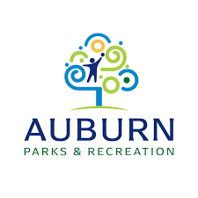

By: Lilly Mills, Ariel Wright, Aaliyah Barber, Jocelyn Smith
School of Communication and Journalism, Auburn University
PRCM 4500: Campaigns
Dr. Brunner-Johnson
April 20, 2026

Tables of Content

Executive Summary……………………………………………………………3
Research………………………………………………………………………..5
Planning……………………………………………………………………….16
Implementation………………………………………………………………..23
Evaluation……………………………………………………………………..29
Work Cited…………………………………………………………………………..37
Appendix…………………………………………………………………………,....38

Executive Summary
Auburn Parks and Recreation’s mission is to enrich the lives of residents by providing welcoming parks, facilities, and programs that promote inclusive play, wellness, and community connection. Since 1970, the department has built a strong reputation, especially for its youth programs, and maintains a favorable public perception. However, this awareness has not translated into consistent sponsor engagement. The organization faces ongoing challenges due to decentralized communication. Individual coaches manage their own sponsorship outreach, leading to inconsistent messaging, limited follow‑up, and minimal sponsor stewardship. Although Auburn Parks and Rec uses social media, email‑blast software, and traditional advertising, these channels lack unified branding and strategic promotion. Public engagement remains low, and past sponsors have reported poor communication and limited acknowledgment, creating a trust gap that must be addressed. Our campaign aims to increase sponsorships by 25 percent across all tiers by strengthening donor‑focused communication and rebuilding trust. The campaign centers on improving clarity, consistency, and transparency in all sponsor‑related messaging to ensure a more professional and reliable experience. We developed two primary strategies to support this goal. Create a structured, year‑round communication system that ensures every past sponsor receives timely updates and personalized outreach. Develop clear, accessible, and visually engaging tools that show sponsors how their contributions directly support youth programs.

Introduction
Auburn Parks and Recreation, a department of the City of Auburn, has served the community since the late 1940s, when the city opened Felton Little Park and began its investment in public recreation. Over the decades, the department has expanded into a major provider of parks, youth sports, community programs, and cultural facilities, becoming a central contributor to Auburn’s quality of life. Its competitive landscape includes Opelika Parks and Recreation, which offers similar youth leagues and community programs, and Auburn University Campus Recreation, which attracts the large student population seeking fitness and wellness activities. Because many local business owners work in Auburn but live in Opelika, sponsorship loyalties may also lean toward Opelika’s system. This environment underscores the need for a cohesive, strategic communications campaign that strengthens Auburn Parks and Recreation’s visibility and positions the department as the most community‑focused and reliable partner for local engagement and sponsorship.

Research
Situational Analysis
The issues the campaign will address
The department enjoys a positive public image, but this awareness has not translated into consistent sponsor engagement. Sponsorship outreach is decentralized, handled individually by team members, leading to inconsistent messaging, limited follow‑up, and weak sponsor stewardship. Public engagement on social media is also low, and past sponsors have reported poor communication and a lack of acknowledgment, creating a trust gap. The department operates in a competitive environment that includes Opelika Parks and Recreation and Auburn University Campus Recreation, both of which attract overlapping audiences.
Primary Publics
The public's awareness of the organization indicates many responders are familiar with Auburn Parks and Recreation. On Q20 of our survey, 25% of respondents were unaware of the sponsorship opportunities. This shows that while the organization is known, the details are not as widely understood. Their understanding of sponsorship opportunities is more limited and often shaped by what they see at events, on signage, and through city communications. This suggests that much of the information the public receives about sponsorships is not promoted through targeted messaging or detailed outreach. The public's involvement with the organization shows a more moderate level of engagement among the respondents. On Q7, 32% of responders said they were sponsors before 2023, and 30% were just sponsors in 2026. A portion of the public has been involved in sponsorship in the past and currently, but a portion of the community has not yet participated.
Public awareness of a topic or campaign largely comes from email communication. On Q8, 72% of respondents said Auburn Parks and Recreation used email to inform them of the sponsorship opportunity. Additionally, 25% chose "other" as a form of communication, indicating that while email is the most popular method, other channels have a role in reaching the public. Email is the primary communication tool for informing the public about the topic or campaign. This helps us understand that email communication is a key source of information for those who are aware of the campaigns. Additionally, responses to Q21 indicate that the public or past sponsors would like to be informed through Facebook (52%), Instagram (36%), and Word-of-Mouth (48%), as these are channels that unaware survey takers identify as channels they check regularly.

Demographics and Psychographics
Survey respondents predominantly fell into the following age ranges: 35-44 (35%), 45-54 (17%), and 55-64 (22%) (Figure VI). Additionally, of those who had sponsored a team or event in the past, almost all were business owners, as individuals typically do not sponsor, whereas business entities do. 66% of business owners who took the survey had been in business in the Auburn-Opelika area for 7+ years, with 48% of those survey takers running a small business, defined as a business with 1-50 employees (Figure VII). Thus, potential future sponsors who have shown engagement with the organization by voluntarily taking the survey are predominantly small business owners who have been established in the area for many years. This indicates that Auburn Parks and Recreation is likely to do well with this base when seeking sponsors and should be targeted by future public relations efforts.
Additionally, data gathered from the open-ended survey questions indicate that many respondents are motivated by community impact, personal connections, and the opportunity for family members to benefit from the sponsorship. Many sponsors indicated that having children or grandchildren involved in sports or events made them more likely to sponsor. Thus, we believe that capitalizing on community connections is key to any future sponsorship public relations campaigns.

Survey Data
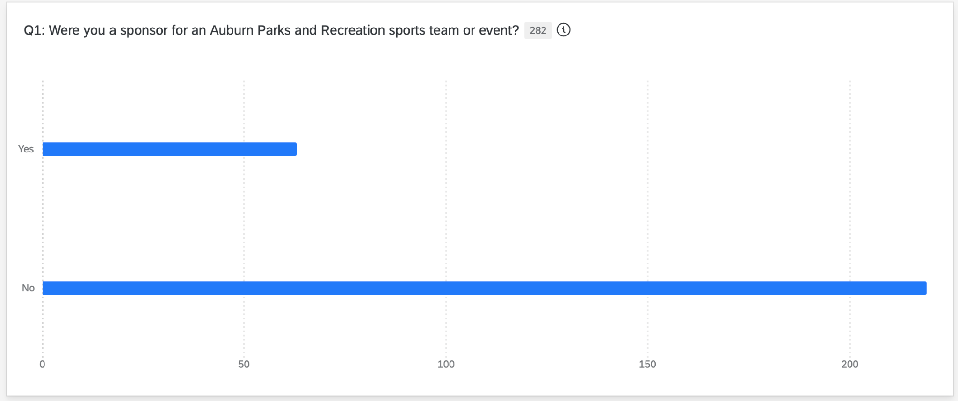
The survey conducted on behalf of Auburn Parks and Recreation was open from February 23rd to March 6th at 5 p.m. Central Standard Time. There were 303 respondents; 78% had not sponsored a team or event in the past, while 22% had (Figure I).

Past sponsors were asked a series of questions about their experience with sponsorship and their likelihood of sponsoring again. In contrast, non-sponsors were asked about their awareness of the opportunity and their rationale for not sponsoring. Trends in answers from both sponsors and non-sponsors indicated that a lack of strong communication was a barrier to effective cultivation and stewardship of sponsors.
For instance, among past sponsors, 51% reported not receiving any follow-up communication after becoming a sponsor, while 49% reported receiving at least some follow-up communication (Figure II).
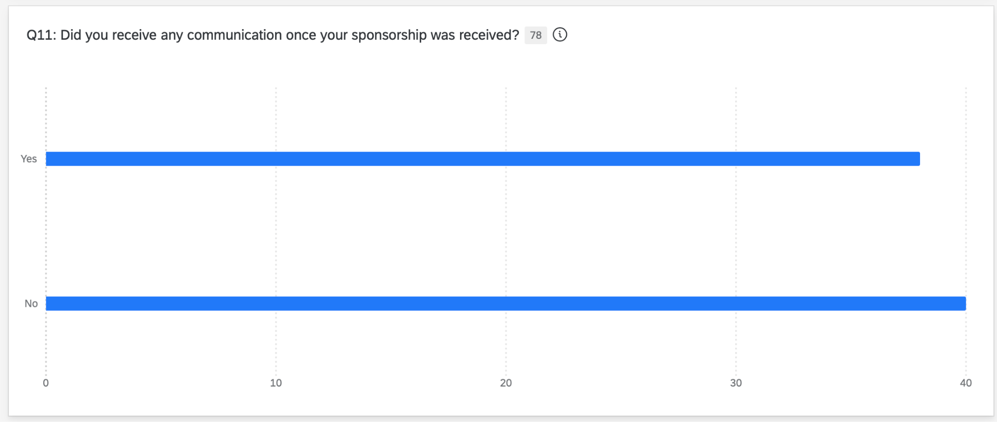
Many sponsors who indicated that they did not receive communications from the organization elaborated in the open-ended follow-up that they would have appreciated receiving follow-up communication from the organization that included greater clarity about where their money went and more engaging, direct outreach. Additionally, people wished they could have more personal connections with both the organization and the team. This demonstrates a missed opportunity for Auburn Parks and Recreation to stay connected with sponsors and create an emotionally impactful experience that makes sponsors more inclined to get involved with the organization in the future.
Furthermore, among those who received follow-up communications, the assessment of this communication's efficacy varied widely. Of those who received follow-up communication, 21% rated it as Excellent, 33% as Good, 39% as Fair, and 7% as Poor or Very Poor (Figure IV).
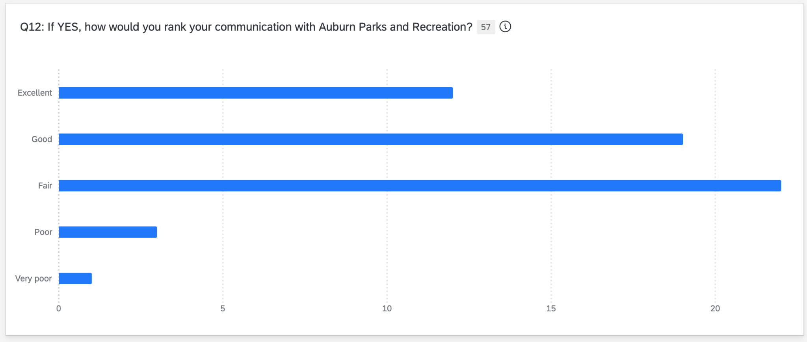
While over half of respondents had favorable views of the communication received, close to half had neutral or negative views. Taken together with the majority of respondents indicating they were not contacted at all, it can be inferred that communication with sponsors is an issue that needs to be addressed in future campaigns. Additionally, of those surveyed, 25% were Extremely Likely to sponsor again, 25% were Likely, 22% were Neutral, 15% were Unlikely, and 13% were Extremely Unlikely (Figure V).
Again, about half of the respondents had a positive enough experience to consider sponsoring a team or event again. In contrast, about half had a neutral or negative experience, indicating that the organization should work to maintain stronger relationships with past sponsors to keep them engaged in future campaigns.

Survey Questions and Data
Q1: Were you a sponsor for an Auburn Parks and Recreation sports team or event?
The results indicate that a majority of respondents (78%) have not previously sponsored an Auburn Parks and Recreation team or event, while only 22% reported prior involvement. This suggests that although the organization is relatively well known, sponsorship participation remains limited.
- Yes: 63 responses
- No: 219 responses
Q2: What year were you a sponsor?
Responses to this question show that sponsorship participation has occurred across multiple years, with slightly higher involvement before 2023 and in recent years, such as 2025 and 2026. This indicates that Auburn Parks and Recreation has maintained a base of both long-term and recent sponsors.
- 2026: 19 responses
- 2025: 18 responses
- 2024: 4 responses
- 2023: 2 responses
- Before 2023: 20 responses
Q3: What forms of communication did Auburn Parks and Recreation use to make you aware of the sponsorship opportunity? (Select all that apply)
The data reveals that email is the primary method used to inform respondents about sponsorship opportunities, with significantly higher responses than any other communication channel. Other platforms, such as Facebook, Instagram, and traditional media like print and radio, were used far less frequently.
- Email: 67
- Facebook: 7
- Instagram: 2
- Radio ads: 1
- Print ads: 3
- Leisure Link: 7
- MyRec: 10
- Auburn Chamber e-Newsletter: 8
- Other: 23
Q4: What forms of communication did Auburn Parks and Recreation use to contact you directly? (Select all that apply)
Email was also the most common method of direct communication with respondents. However, a notable portion reported limited or no direct contact.
- Email: 66
- In person: 10
- Other: 9
- MyRec: 7
- Leisure Link (e-Notifier): 4
- Facebook: 2
- Auburn Parks and Recreation did not contact me directly: 26

Q5: What do you find effective or ineffective about Auburn Parks and Recreation’s sponsorship outreach efforts?
Responses indicated that many participants found current outreach efforts to be inconsistent and lacking personalization. While some found communication effective, others noted a lack of clarity and follow-up.
Q6: Did you receive any communication once your sponsorship was received?
Responses were nearly evenly split between those who received communication after sponsoring and those who did not. This indicates inconsistency in follow-up practices.
- Yes: 38
- No: 40
Q7: If yes, how would you rank your communication with Auburn Parks and Recreation?
Among those who received communication, responses varied widely from excellent to poor. While some respondents had positive experiences, a significant portion rated communication as fair or lower.
- Excellent: 12
- Good: 19
- Fair: 22
- Poor: 3
- Very Poor: 1
Q8: If not, what kind of information or communication would you have liked to receive from Auburn Parks and Recreation?
Respondents expressed a desire for more detailed and consistent communication after sponsoring. Many wanted updates on how their contributions were used and the impact they made.
Q9: What aspects of the sponsorship experience did you appreciate?
Participants noted that they appreciated the opportunity to support the community and local youth. Personal connections, such as having family involved in programs, were also significant motivators.
Q10: How likely are you to sponsor a team or event again?
Responses were mixed, with roughly half of the participants indicating they were likely or extremely likely to sponsor again. The remaining respondents were neutral or unlikely.
- Extremely likely: 20
- Likely: 20
- Neutral: 17
- Unlikely: 12
- Extremely unlikely: 10
Q11: If you answered “Unlikely” or “Extremely Unlikely,” which of the following are barriers? (Select all that apply)
The most common barriers included cost, lack of incentives, and perceived lack of business benefit. Some respondents also noted inconsistent communication and unclear messaging.
- Cost of sponsorship: 8
- Lack of incentives: 9
- Did not benefit my business: 6
- Inconsistent communication: 2
- Lack of follow-up: 1
- Unclear messaging: 1
- Other: 19

Q12: Which of the following would make you likely to sponsor a team or event again? (Select all that apply)
Respondents indicated that recognition, such as social media and website acknowledgment, would increase their likelihood of sponsoring. Other incentives, such as photos, schedules, and thank-you notes, were also valued.
- Social media recognition: 40
- Website recognition: 37
- Recognition on print material (signage/program brochure): 35
- Team or event photo: 27
- Provide a schedule for the sponsored team or event: 22
- Thank you notes: 18
- Updates about the team’s season: 18
- Radio recognition: 14
- Other: 16
Q13: At the conclusion of the sports season or event, how would you like to be followed up with by an Auburn Parks and Recreation staff member?
Email updates, thank-you notes, and season results were the most preferred follow-up methods. Less preferred options included event wrap-ups and digital content.
Respondents ranked follow-up methods in order of importance. The most preferred options included:
- Email updates
- Thank you notes
- Season/post-season schedule or season results
Less preferred options included:
- Event wrap-up
- Digital photo/video content
- Other
Q14: If there are any other questions or information you have about sponsoring an event or sports team with Auburn Parks and Recreation, please list them here:
Responses reflected a desire for clearer information about sponsorship opportunities and benefits. Participants also sought more transparency and guidance throughout the process.
Q15: If you have not sponsored a sports team or event, why not? (Select all that apply)
Financial concerns were the most common reason respondents had not sponsored. Other factors included a lack of awareness and relevance to their business.
- Financial concerns: 67
- Other: 49
- Relevance to business or personal interests: 46
- Awareness of opportunity: 43
- Return on investment for business: 14
Q16: If you were not aware of the opportunity, which of the following channels do you regularly receive information from? (Select all that apply)
Respondents indicated that Facebook, word of mouth, and Instagram are commonly used channels for receiving information. This contrasts with the organization’s reliance on email.
- Facebook: 77
- Word of Mouth: 71
- Instagram: 54
- MyRec: 47
- Leisure Link: 43
- Auburn Chamber e-Newsletter: 32
- Print ads: 22
- Other: 19
- Radio ads: 18
Q17: How much would you be willing to contribute to help sponsor a team or event?
Most respondents indicated a willingness to contribute lower monetary amounts, particularly under $300. Few respondents were willing to contribute higher amounts.
- Less than $100: 94
- $100–$300: 62
- $301–$500: 16
- $501–$700: 4
- More than $900: 2
Q18: What would make you likely to sponsor a sports team or event? (Select all that apply)
Discounts on sports registration and recognition opportunities were the most appealing incentives. Respondents also valued visibility through various communication channels.
- Discount on sports registration for your child: 89
- Social media recognition: 54
- Other: 52
- Recognition on print material: 51
- Website recognition: 41
- Radio recognition: 14
Q19: How old are you?
The majority of respondents fell within the 35–44, 45–54, and 55–64 age ranges. This suggests that middle-aged individuals, many of whom are likely business owners, make up the primary audience.
- 19–24: 1
- 25–34: 13
- 35–44: 34
- 45–54: 17
- 55–64: 22
- 65+: 11
Q20: What is your gender?
The sample included more female respondents than males, with very few selecting “prefer not to say.”
- Male: 37
- Female: 59
- Prefer not to say: 1
Q21: How long has your organization been in business in the Auburn-Opelika area?
Most respondents reported being in business for 7+ years. This suggests that established businesses are more likely to engage with Auburn Parks and Recreation.
- Less than 1 year: 8
- 1–3 years: 9
- 4–6 years: 6
- 7+ years: 45
Q22: What type of organization are you?
Responses varied across different types of organizations, indicating a diverse sponsor base. This suggests that sponsorship opportunities appeal to a wide range of businesses. Tailoring messaging to different industries may improve engagement.
Q23: What field is your organization in?
Respondents represented a variety of industries, with professional services, construction, and healthcare being the most common. This diversity highlights the broad appeal of sponsorship opportunities.
- Professional Services: 20
- Construction and Development: 11
- Healthcare: 9
- Non-profit: 6
- Retail: 4
- Food and Beverage: 3
- Other: 26

Planning
As demonstrated by our comparative analysis of industry best practices, theoretical frameworks, and survey responses, Auburn Parks and Recreation would benefit from prioritizing strengthening its relationship with past sponsors and building a reputation as an organization that values and communicates with its supporters. Thus, the overarching goal of our campaign is as follows:
- Develop a consistent and relationship‑focused communication system that rebuilds trust with past Auburn Parks & Recreation youth‑sports sponsors, increases their understanding of sponsorship impact, and encourages long‑term partnership and repeat sponsorship.
As such, the guiding objectives of our campaign are as follows:
- Increase the percentage of past Auburn Parks & Recreation sponsors who report receiving consistent follow‑up communication from 49% baseline to 75% within 12 months, as measured by a post‑campaign survey of all past sponsors.
- Increase the number of past sponsors who choose to sponsor again from the current baseline (e.g., last year’s returning‑sponsor count) by 25% within the next sponsorship cycle, as measured by Auburn Parks & Recreation’s annual sponsorship enrollment records.

In the Handbook of Public Relations, Kathleen Kelly discusses the importance of stewardship, arguing that the practice should be implemented as the final step in each public relations campaign. Her argument hinges on research in the field of relationship management that suggests “factors such as trust, involvement, and commitment – developed through multi-year efforts – differentiate members who react positively toward an organization from those who react negatively” (Kelly, 2001, p. 279). While reaching new sponsors is important, the most strategic campaign structure would be to target past sponsors who have already demonstrated a capacity and interest to support sports teams and events financially. However, our research indicates that past sponsors have varying levels of trust in the organization, with many stating that they were not adequately communicated with or thanked following their decision to sponsor. Therefore, our campaign is primarily focused on correcting that negative perception and assuaging fears by creating follow-up communication materials for both private and public channels that showcase Auburn Parks and Recreation’s commitment to keeping sponsors engaged and grateful for their support.
Additionally, the New York City-based firm 5W Public Relations asserts that public relations is essential for building connections between sponsors and fans in its article “The Importance of PR in Sponsoring Sports Teams and Events.” They argue that to implement effective sports and events public relations campaigns, organizations must “start with clear objectives and measurement frameworks, focus on authentic storytelling that aligns brand and sports values, develop comprehensive media strategies across all relevant platforms, create engaging behind-the-scenes content, and maintain consistent measurement and optimization processes,” (5WPR, 2025). The bulk of this proposal focuses on outlining our proposed objectives and means of measuring success, ideas for creating authentic narratives that emphasize sponsor impact, and suggestions on how to continue to collect and incorporate feedback from past sponsors, as we believe that Auburn Parks and Recreation’s sponsorship campaign could benefit from incorporating some of the strategies outlined in this firm’s guide to industry best practices.

Theoretical Frameworks
After surveying best practices in the field, we identified two theoretical frameworks that will inform our campaign development: relationship management theory and elaboration likelihood theory. Relationship management theory has been discussed extensively in the existing literature on donor stewardship and, as such, is central to our campaign. This theory posits that relationships are central to public relations and identifies the dimensions of these relationships as openness, trust, involvement, investment, and commitment. These five dimensions are especially relevant to the relationship between an organization and its philanthropic supporters, as people need to have strong trust in and a sense of appreciation from the entities to which they provide voluntary financial support.
The elaboration likelihood theory was chosen to inform the rhetorical elements within our campaign materials. The theory states that decision-making is dictated by both the central, logical route and the peripheral, emotional route. The survey conducted on behalf of our client indicated that many community members struggle to justify the decision to sponsor a team when approaching the opportunity logically. “Many stated that the restrictive cost outweighed the benefits. They felt that the decision to sponsor had a lower return on investment than they would have liked for their business” (Figure VIII). “However, on the flip side, many stated that they enjoyed the connection to the community and the ability to support local youth programs that the sponsorship program provides” (Figure IX). Therefore, our group aims to focus primarily on creating emotionally resonant communications materials rather than logistically-based ones. While we recognize the importance of incorporating logic-driven messaging into our materials, the evidence indicates that many are not moved to action by this messaging. As such, we aim to reach those community members by supplementing the facts about the sponsorship program with materials that speak to its emotional aspect.

Key Publics and Messages
The key public for our campaign is past sponsors. Past sponsors include business owners and independent contractors who work in the Auburn and/or Opelika area. Most are involved with small or medium-sized businesses. “In general, a small business typically has fewer than 500 employees, but according to the U.S. Small Business Administration (SBA), the real answer depends on industry, revenue and number of employees”(How are small businesses defined?). These include local businesses such as The Irritable Bao, The Potting Shed, and Auburn Art. We believe focusing on building a strong relationship with those who have already demonstrated a propensity and desire to sponsor is the most effective and strategic usage of resources, both because the organization knows their resources are being invested into a business that is interested in their programs, but also because keeping past sponsors happy is essential to encouraging positive word of mouth to potential new sponsors. If a significant portion of past sponsors remain dissatisfied with the communication they received from the organization, it becomes much harder to grow sponsorship numbers in the future. This is evidenced by the Handbook of Public Relations, where Kelly points out that “perceptions of the relationship between an organization and members of a key public significantly influence loyalty to the sponsoring organization” (Kelly, 2001, p. 282). In other words, if potential sponsors perceive a positive relationship with past sponsors, they are more likely to get involved themselves.
With this loyalty in mind, we developed two key messages that inform our campaign and reiterate Auburn Parks and Recreation’s commitment to its sponsors. Our key messages are as follows:
- We’re grateful for your continued support, and we’re excited to continue to celebrate your impact.
- We’re here to support you just as you support our community.
These messages will be interspersed through many of our communication materials and echoed throughout our campaign.
Strategies and Tactics
With that in mind, we developed two primary strategies that align with our proposed objectives and key messages. Our strategies are as follows:
- Create a structured, year‑round communication system that ensures every past sponsor receives timely updates, personalized outreach, and clear points of contact.
- Develop clear, accessible, and visually engaging tools that show sponsors exactly how their contributions support youth sports programs.
The first campaign strategy is based on relationship management theory, while the second is based on elaboration-likelihood theory. The first strategy was developed with the first objective of increasing the number of past sponsors who reported receiving consistent communication from Auburn Parks and Recreation throughout the campaign. In contrast, the second strategy was developed to increase the number of returning sponsors, as we hope that developing emotionally impactful and engaging campaign tools will incentivize sponsors to continue providing support.
In the Handbook of Public Relations, Kathleen Kelly discusses the importance of stewardship, arguing that the practice should be implemented as the final step in each public relations campaign. Her argument hinges on research in the field of relationship management that suggests “factors such as trust, involvement, and commitment – developed through multi-year efforts – differentiate members who react positively toward an organization from those who react negatively” (Kelly, 2001, p. 279). While reaching new sponsors is important, the most strategic campaign structure would be to target past sponsors who have already demonstrated a capacity and interest to support sports teams and events financially. However, our research indicates that past sponsors have varying levels of trust in the organization, with many stating that they were not adequately communicated with or thanked following their decision to sponsor. Therefore, our campaign is primarily focused on correcting that negative perception and assuaging fears by creating follow-up communication materials for both private and public channels that showcase Auburn Parks and Recreation’s commitment to keeping sponsors engaged and grateful for their support.
Additionally, the New York City-based firm 5W Public Relations asserts that public relations is essential for building connections between sponsors and fans in its article “The Importance of PR in Sponsoring Sports Teams and Events.” They argue that to implement effective sports and events public relations campaigns, organizations must “start with clear objectives and measurement frameworks, focus on authentic storytelling that aligns brand and sports values, develop comprehensive media strategies across all relevant platforms, create engaging behind-the-scenes content, and maintain consistent measurement and optimization processes,” (5WPR, 2025). The bulk of this proposal focuses on outlining our proposed objectives and means of measuring success, ideas for creating authentic narratives that emphasize sponsor impact, and suggestions on how to continue to collect and incorporate feedback from past sponsors, as we believe that Auburn Parks and Recreation’s sponsorship campaign could benefit from incorporating some of the strategies outlined in this firm’s guide to industry best practices.
Theoretical Frameworks
After surveying best practices in the field, we identified two theoretical frameworks that will inform our campaign development: relationship management theory and elaboration likelihood theory. Relationship management theory has been discussed extensively in the existing literature on donor stewardship and, as such, is central to our campaign. This theory posits that relationships are central to public relations and identifies the dimensions of these relationships as openness, trust, involvement, investment, and commitment. These five dimensions are especially relevant to the relationship between an organization and its philanthropic supporters, as people need to have strong trust in and a sense of appreciation from the entities to which they provide voluntary financial support.
The elaboration likelihood theory was chosen to inform the rhetorical elements within our campaign materials. The theory states that decision-making is dictated by both the central, logical route and the peripheral, emotional route. The survey conducted on behalf of our client indicated that many community members struggle to justify the decision to sponsor a team when approaching the opportunity logically. “Many stated that the restrictive cost outweighed the benefits. They felt that the decision to sponsor had a lower return on investment than they would have liked for their business” (Figure VIII). “However, on the flip side, many stated that they enjoyed the connection to the community and the ability to support local youth programs that the sponsorship program provides” (Figure IX). Therefore, our group aims to focus primarily on creating emotionally resonant communications materials rather than logistically-based ones. While we recognize the importance of incorporating logic-driven messaging into our materials, the evidence indicates that many are not moved to action by this messaging. As such, we aim to reach those community members by supplementing the facts about the sponsorship program with materials that speak to its emotional aspect.

Concept
To implement these strategies, our team has developed five digital and five traditional tactics to help Auburn Parks and Recreation craft consistent, appealing communication that strengthens relationships with sponsors. Within our overarching campaign, we have one mini-campaign focused on sharing feel-good stories about the community impact of sponsorship, called “Your Sponsorship Dollars at Work,” which many of our tactics are part of. All tactics that do not fall under this mini-campaign are intended to help establish a framework for clear, consistent communication between Auburn Parks and Recreation and its sponsors.

Implementation
These campaign materials were developed for past sponsors, but with slight adaptation, they can also reach new sponsors if the organization wishes. The ten digital and traditional tactics are as follows:

DIGITAL
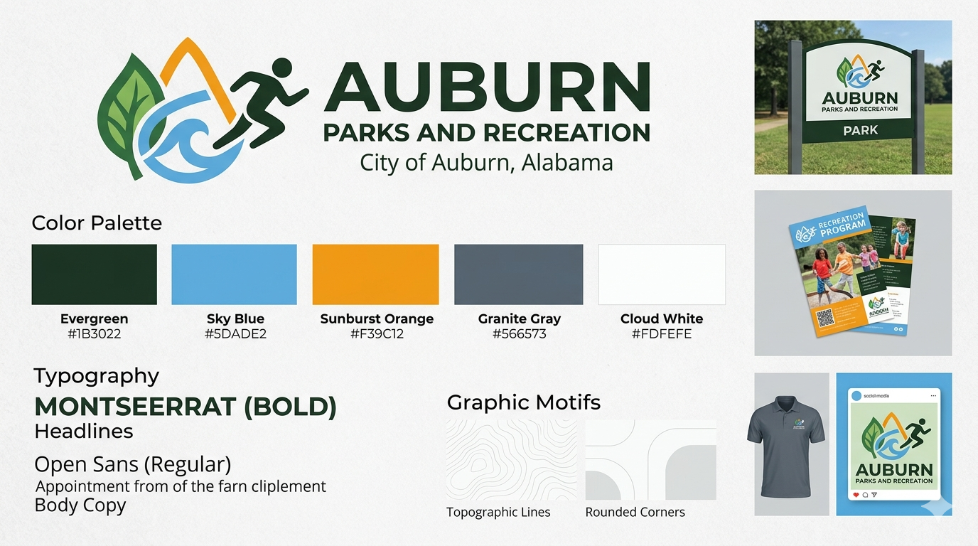
- A branding guideline kit with colors, fonts, and design elements that can be used in all communications materials. The kit would include a clearly defined color palette, approved fonts, logo usage rules, and design elements that reflect the organization’s identity. It would outline how these elements should appear in sponsorship packets, email campaigns, social media graphics, flyers, thank‑you notes, and community‑facing materials. This kit would be used year-round by staff members creating sponsor packets, social posts, email newsletters, signage, brochures, and thank-you materials. It would be used internally in the department office and across all public-facing channels to ensure every communication looks connected and professional.

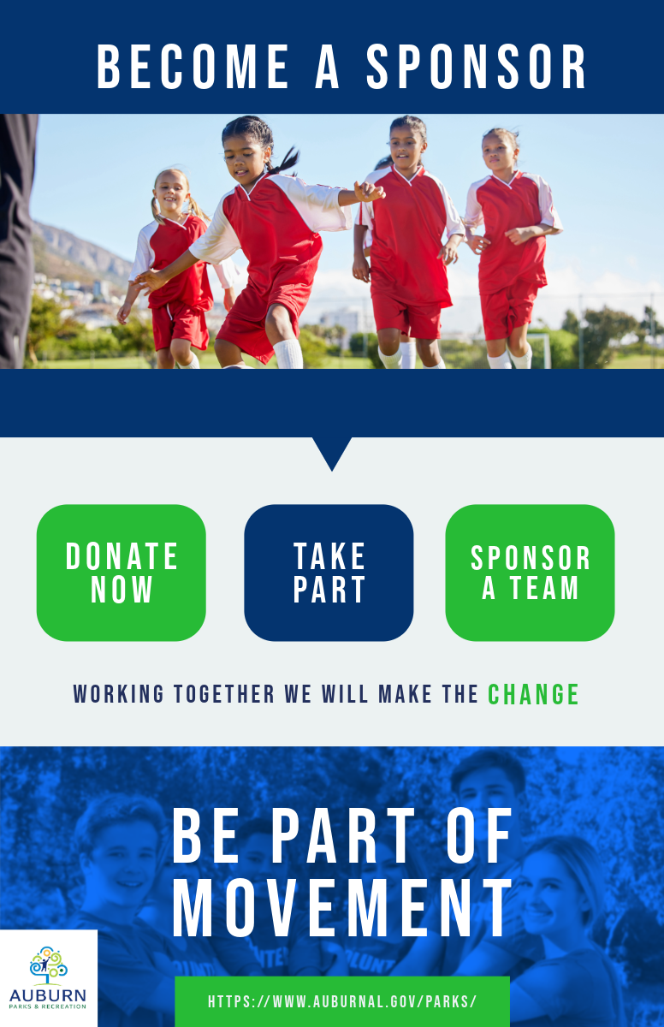
- An email campaign should include a personalized Auburn Parks and Recreation header graphic that immediately connects the sponsor opportunity to the local community. The email would also include a button graphic that says “Become a Sponsor” in Auburn Parks and Recreation branding. This tactic would be used before each sports season and before major community events when the department begins sponsorship outreach. It should be sent through email to past sponsors, local businesses, and prospective sponsors. It would be used through the organization’s email platform and could also be adapted for PDFs or digital sponsorship packets.

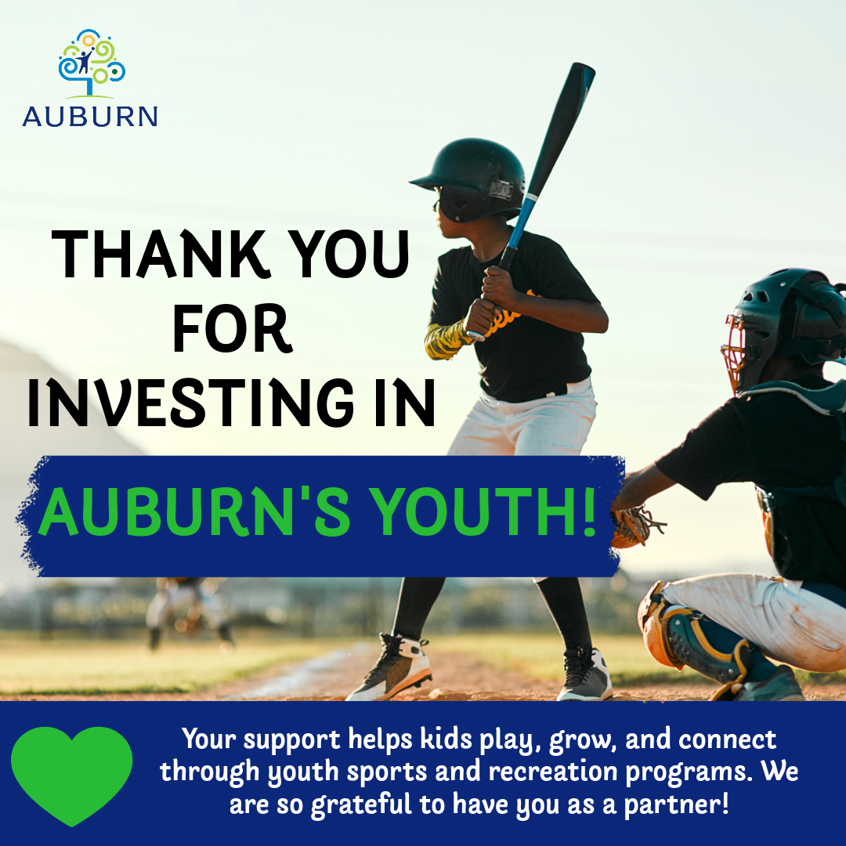
- A mock community-focused Facebook post to share the ways the local community benefits from sponsor support; part of the “Your Sponsorship Dollars at Work” mini-campaign. This tactic would be used immediately after a sponsorship commitment is received. It would be sent directly to sponsors through email and would serve as one of the first stewardship touchpoints in the campaign. This graphic helps make the message feel more personal and appreciative rather than transactional.
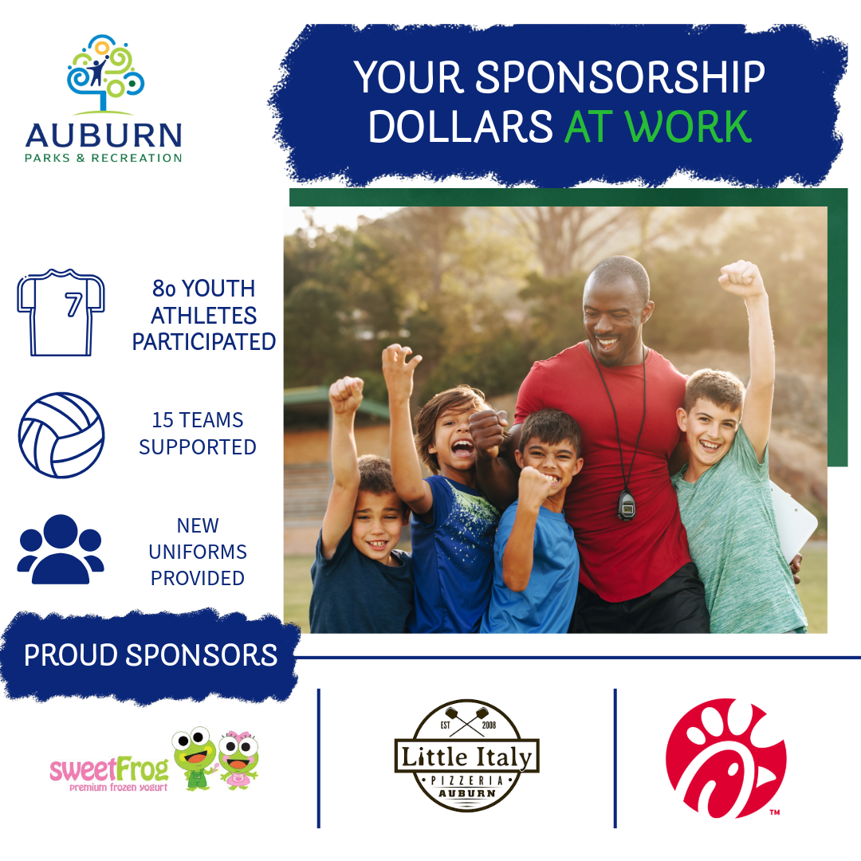
- A mock business-focused LinkedIn post that highlights how businesses can benefit from sponsorship while also supporting the community; part of the “Your Sponsorship Dollars at Work” mini-campaign. This tactic would be used at the end of each sports season or major event. It would be sent by email and could also be uploaded to Auburn Parks and Recreation’s website or included in digital newsletters. This is an important stewardship tool because it shows impact and closes the loop.

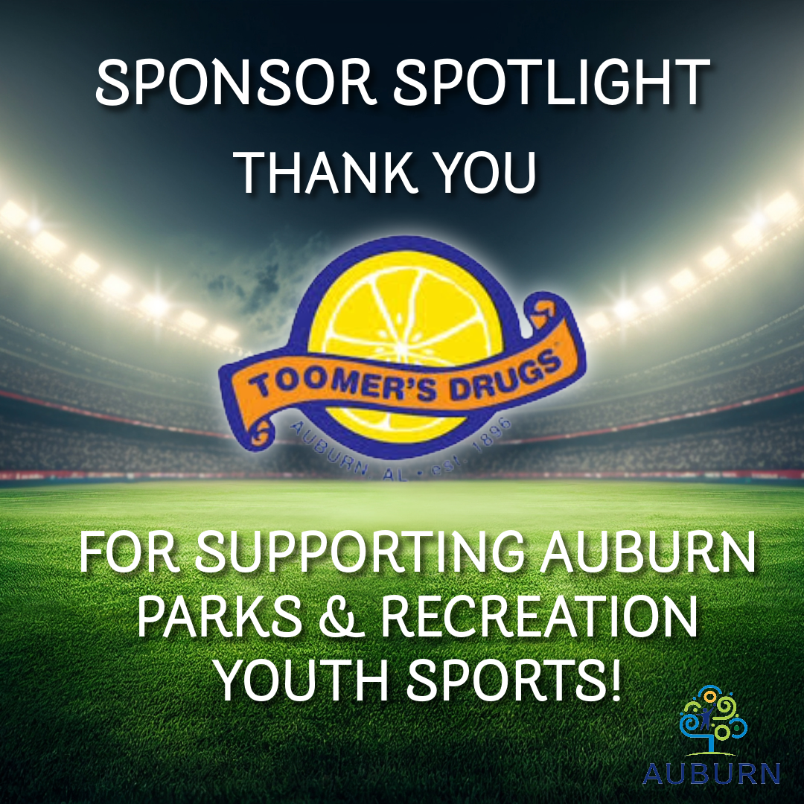
- A mock “Sponsor Shoutout” for Facebook and LinkedIn that highlights a business that has sponsored a team or event. The post could highlight how sponsorship supports uniforms, equipment, and accessible recreation for local children. This tactic would be used monthly throughout the campaign, especially during active sports seasons and community event periods. It would be posted on Auburn Parks and Recreation’s Facebook page.

TRADITIONAL
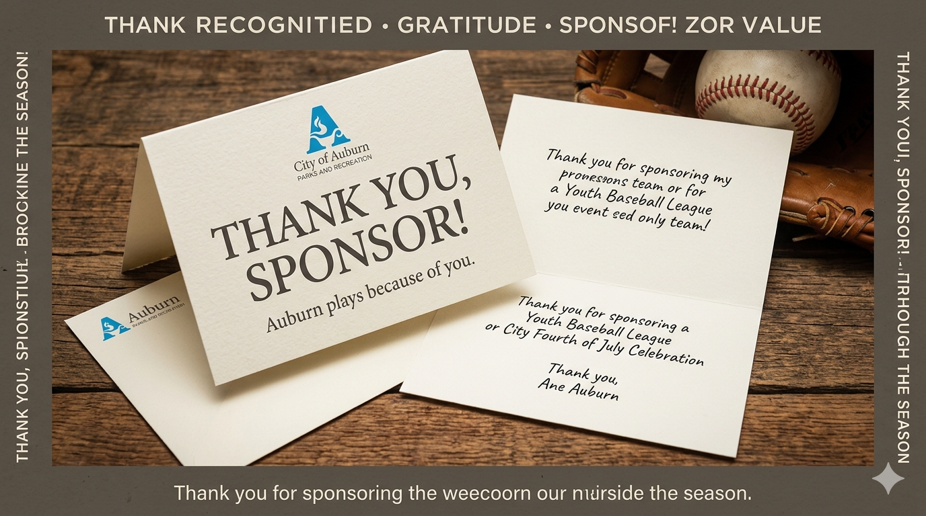
- Printed thank you notes to be mailed to each sponsor after they agree to sponsor a team or event. This tactic would be used throughout the season whenever a sponsor is secured or recognized publicly. It would appear on Auburn Parks and Recreation social media pages and help reinforce recognition, gratitude, and sponsor value.

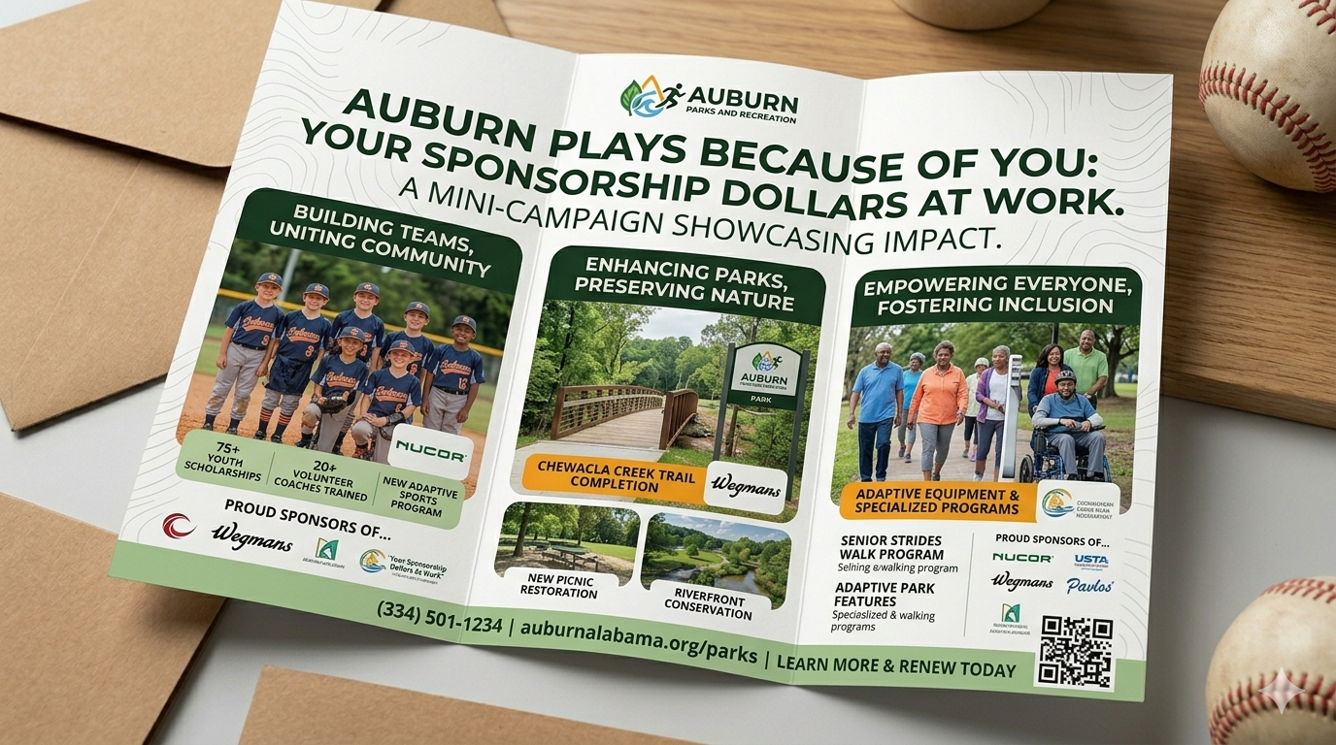
- A brochure that shares multiple success stories from teams or events that were funded by sponsorship will be mailed to sponsors as part of the “Your Sponsorship Dollars at Work” mini-campaign. This brochure would be used during sponsor outreach and post-season stewardship. It could be mailed to past sponsors, handed out at meetings, included in sponsorship packets, and displayed at Auburn Parks and Recreation events or in office spaces.

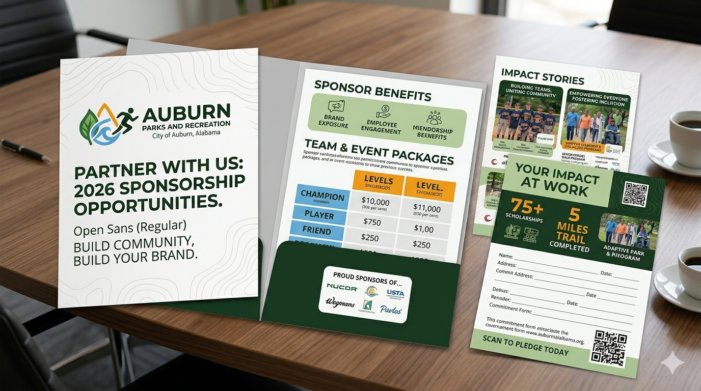
- A redesigned print sponsorship packet that utilizes Auburn Parks and Recreation branding. This tactic would be used at the beginning of each sponsorship cycle, during meetings with businesses, and at community networking events. It would be distributed in person, mailed to businesses, or shared as a printable PDF. This is one of the most important materials because it serves as the main information piece for sponsor recruitment.
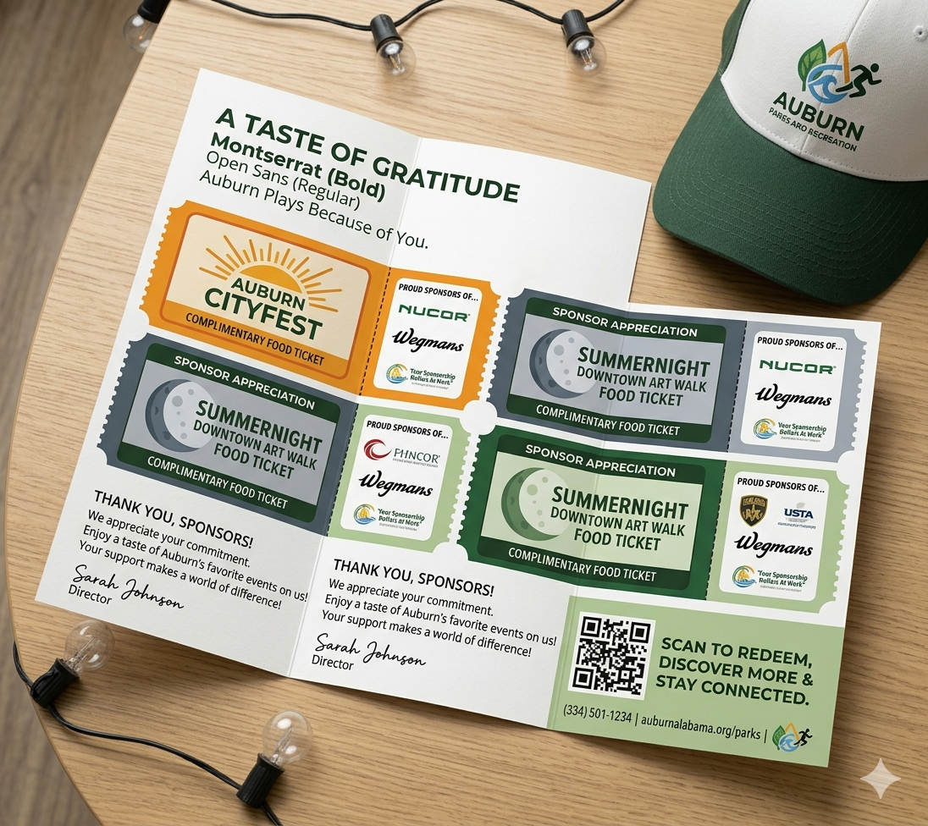
- A package of free food tickets for Auburn CityFest and SummerNight Downtown Art Walk, encouraging sponsors to get involved with the community and showing gratitude for their support. This tactic would be used after sponsorship commitments are made or during sponsor appreciation periods. It would be mailed or hand-delivered to sponsors as a way to thank them while encouraging them to stay connected to the local events they help make possible. This tactic works best as a relationship-building tool rather than a recruitment piece.
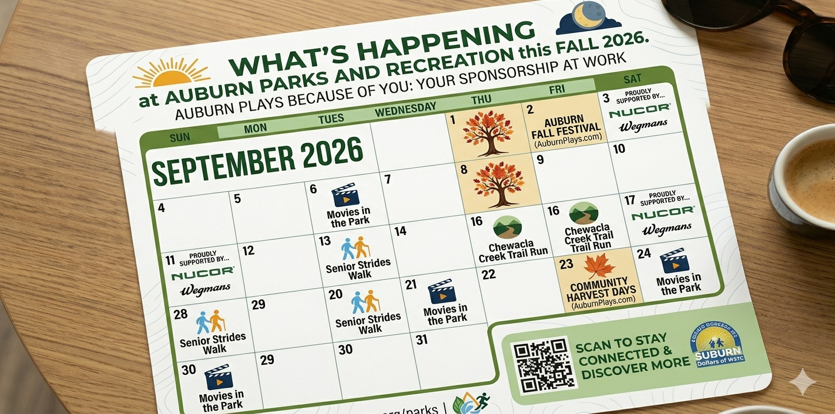
- A calendar displaying the events Parks and Recreation will host during the month. A headline such as “What’s Happening at Auburn Parks and Recreation This Month” would make it feel useful and engaging. This tactic would be used monthly and shared in print at community centers, city buildings, sponsor offices, and Auburn Parks and Recreation facilities. It could also be turned into a digital version for email and social media. This piece helps keep sponsors informed and reinforces that they are supporting an active, visible community organization.

We believe that the aforementioned goal, objectives, key messages, strategies, and tactics will resonate with our key public and help build a strong partnership between our client and their sponsors.

Evaluation
To determine the effectiveness of our campaign in increasing sponsorship support for Auburn Parks and Recreation’s youth sports programs, we will evaluate outcomes based on sponsorship growth, awareness levels, and the impact on youth participation.
The primary goal of our campaign is to increase public outreach to local businesses to secure more corporate sponsorships that help fund youth sports participation for the upcoming fall season. By expanding awareness of sponsorship opportunities and demonstrating their impact, the campaign aims to ensure that more children can participate in Auburn Parks and Recreation programs regardless of financial barriers.
We have developed objectives and evaluation methods :
- Informational
The campaign was designed to strengthen Auburn Parks & Recreation’s relationships with past youth‑sports sponsors by improving communication consistency and demonstrating the tangible impact of sponsorship. Guided by relationship management theory and the elaboration‑likelihood model, the campaign aimed to rebuild trust, increase sponsor satisfaction, and encourage long‑term partnership.
Its primary goal was to establish a year‑round, relationship‑focused communication system, supported by two measurable objectives: increasing the percentage of past sponsors who report receiving consistent follow‑up communication to 75% within 12 months, and increasing the number of returning sponsors by 25% in the next sponsorship cycle.
Past sponsors, primarily small and medium‑sized local businesses, were identified as the key public due to their existing interest and influence on community perceptions.
- Motivational
To increase awareness of Auburn Parks and Recreation’s sponsorship opportunities among local businesses and improve their willingness to support youth sports programs by 20%, as measured through pre‑campaign and post‑campaign surveys. This objective focuses on motivating businesses to view sponsorship as a meaningful way to invest in the community and provide more children with access to recreational opportunities.
- Behavioral
The behavioral evaluation assesses whether the campaign successfully influenced past sponsors to take measurable actions aligned with its objectives. Because the campaign aimed to increase communication consistency and encourage repeat sponsorship, behavioral outcomes are evaluated using two key numerical indicators:
(1) whether the percentage of past sponsors reporting consistent follow‑up communication increased from the baseline survey percentage to the campaign goal of 75%, and
(2) whether the number of returning sponsors increased by 25% compared to the previous sponsorship cycle. Behavioral data is collected through post‑campaign surveys, sponsorship enrollment records, and engagement metrics from communication channels such as email, social media, and MyRec.

Limitations and Solutions:
1. Limitation: Limited Baseline Data on Sponsor Perceptions
Because Auburn Parks and Recreation had inconsistent communication practices before the campaign, baseline data on sponsor satisfaction and communication expectations may be incomplete or unreliable.
Solution: Strengthen data collection by conducting annual standardized surveys and maintaining consistent sponsor records to ensure accurate year‑to‑year comparisons.
2. Limitation: Small Sample Size of Past Sponsors
The number of past sponsors in the Auburn–Opelika area is relatively small, which may limit the statistical significance of survey findings and behavioral outcomes.
Solution: Expand outreach to include potential and lapsed sponsors to increase the sample size and gather broader insights to inform future communication strategies.
3. Limitation: Variability in Sponsor Communication Preferences
Sponsors differ in how they prefer to receive information (email, social media, in‑person, etc.), which may reduce the effectiveness of a single communication channel.
Solution: Implement a multi‑channel communication system and allow sponsors to select their preferred communication method at the beginning of each sponsorship cycle.
4. Limitation: Limited Staff Capacity for Personalized Outreach
Auburn Parks and Recreation may not have the staffing resources to maintain individualized communication with every sponsor year‑round.
Solution: Develop automated communication workflows (e‑newsletters, scheduled updates, templated thank‑you messages) to supplement personalized outreach and reduce staff burden.
Research Instruments:
Q1: Were you a sponsor for an Auburn Parks and Recreation sports team or event?
- Yes
- No
Q2: What year were you a sponsor?
- 2026
- 2025
- 2024
- 2023
- Before 2023
Q3: What forms of communication did Auburn Parks and Recreation use to make you aware of the sponsorship opportunity? (Select all that apply)
- Email
- Facebook
- Instagram
- Radio ads
- Print ads
- Leisure Link
- MyRec
- Auburn Chamber e-Newsletter
- Other
Q4: What forms of communication did Auburn Parks and Recreation use to contact you directly? (Select all that apply)
- Email
- In person
- Other
- MyRec
- Leisure Link (e-Notifier)
- Facebook
- Auburn Parks and Recreation did not contact me directly

Q5: What do you find effective or ineffective about Auburn Parks and Recreation’s sponsorship outreach efforts?
This was an open-ended response question and provided qualitative feedback regarding communication clarity, outreach effectiveness, and opportunities for improvement.
Q6: Did you receive any communication once your sponsorship was received?
- Yes
- No
Q7: If yes, how would you rank your communication with Auburn Parks and Recreation?
- Excellent
- Good
- Fair
- Poor
- Very Poor
Q8: If not, what kind of information or communication would you have liked to receive from Auburn Parks and Recreation?
This was an open-ended response question focused on desired post-sponsorship communication.
Q9: What aspects of the sponsorship experience did you appreciate?
This was an open-ended response question designed to gather feedback on positive aspects of the sponsorship experience.
Q10: How likely are you to sponsor a team or event again?
- Extremely likely
- Likely
- Neutral
- Unlikely
- Extremely unlikely
Q11: If you answered “Unlikely” or “Extremely Unlikely,” which of the following are barriers? (Select all that apply)
- Cost of sponsorship
- Lack of incentives
- Did not benefit my business
- Inconsistent communication
- Lack of follow-up
- Unclear messaging
- Other

Q12: Which of the following would make you likely to sponsor a team or event again? (Select all that apply)
- Social media recognition
- Website recognition
- Recognition on print material (signage/program brochure)
- Team or event photo
- Provide a schedule for the sponsored team or event
- Thank you notes
- Updates about the team’s season
- Radio recognition
- Other
Q13: At the conclusion of the sports season or event, how would you like to be followed up with by an Auburn Parks and Recreation staff member?
Respondents ranked follow-up methods in order of importance. The most preferred options included:
- Email updates
- Thank you notes
- Season/post-season schedule or season results
Less preferred options included:
- Event wrap-up
- Digital photo/video content
- Other
Q14: If there are any other questions or information you have about sponsoring an event or sports team with Auburn Parks and Recreation, please list them here:
This was an open-ended response question used to gather additional sponsor concerns and feedback.
Q15: If you have not sponsored a sports team or event, why not? (Select all that apply)
- Financial concerns
- Other
- Relevance to business or personal interests
- Awareness of opportunity
- Return on investment for business
Q16: If you were not aware of the opportunity, which of the following channels do you regularly receive information from? (Select all that apply)
- Facebook
- Word of Mouth
- Instagram
- MyRec
- Leisure Link
- Auburn Chamber e-Newsletter
- Print ads
- Other
- Radio ads
Q17: How much would you be willing to contribute to help sponsor a team or event?
- Less than $100
- $100–$300
- $301–$500
- $501–$700
- More than $900
Q18: What would make you likely to sponsor a sports team or event? (Select all that apply)
- Discount on sports registration for your child
- Social media recognition
- Other
- Recognition on print material
- Website recognition
- Radio recognition
Q19: How old are you?
- 19–24
- 25–34
- 35–44
- 45–54
- 55–64
- 65+
Q20: What is your gender?
- Male
- Female
- Prefer not to say
Q21: How long has your organization been in business in the Auburn-Opelika area?
- Less than 1 year
- 1–3 years
- 4–6 years
- 7+ years
Q22: What type of organization are you?
This was an open-ended response question.
Q23: What field is your organization in?
- Professional Services
- Construction and Development
- Healthcare
- Non-profit
- Retail
- Food and Beverage
- Other

End of Survey

Behavioral Objective
Increase the number of local businesses that commit to sponsoring Auburn Parks and Recreation youth sports programs by 25% for the upcoming fall season, as measured through Auburn Parks and Recreation’s sponsorship enrollment records. This includes tracking not only businesses that complete a sponsorship commitment, but also those that take measurable steps in the sponsorship process, such as requesting information, attending outreach events, meeting with staff, or beginning the sponsorship application.
For summative evaluation, the same sponsorship database will be analyzed at the end of the campaign to compare final sponsorship commitments against previous years’ totals. This will allow Auburn Parks and Recreation to determine whether the campaign successfully increased the number of sponsoring businesses, strengthened engagement throughout the sponsorship pipeline, and met the targeted 25% growth in sponsorship participation. Additionally, tracking repeat sponsors versus first‑time sponsors will help measure whether the campaign improved long‑term business involvement and strengthened community partnerships.

Works Cited:
“How Are Small Businesses Defined?” How Are Small Businesses Defined? – Colorado Chamber of Commerce, cochamber.com/2024/04/23/how-are-small-businesses-defined-2/.
Kelly, K. (2001). Stewardship: the fifth step in the public relations process. In R. L. Heath
(Ed.) Stewardship: The fifth step in the public relations process (pp. 279-290). SAGE
Publications, Inc., https://doi.org/10.4135/9781452220727.n21
PR, 5W. (2025, April 30). The importance of PR in sponsoring sports teams and events: 5W
pr agency blog. Public Relations Blog | 5W PR Agency | PR Firm.
https://www.5wpr.com/new/the-importance-of-pr-in-sponsoring-sports-teams-and-eve
nts/

Appendix:

Figure I:
Figure II:
Figure IV:
Figure V:
Figure VI:
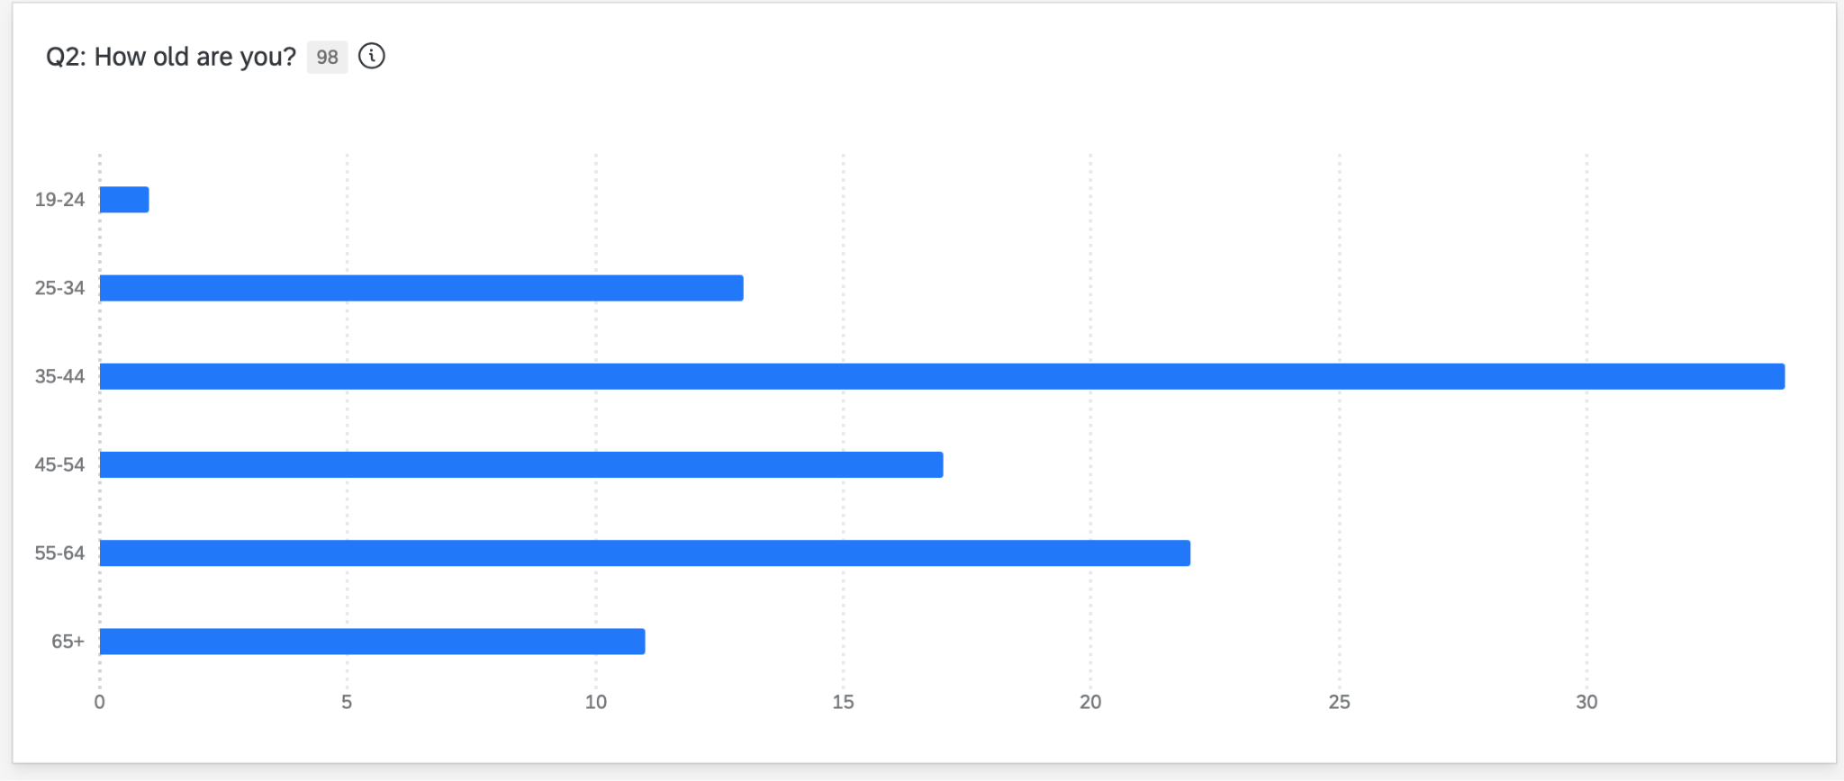
Figure VII:
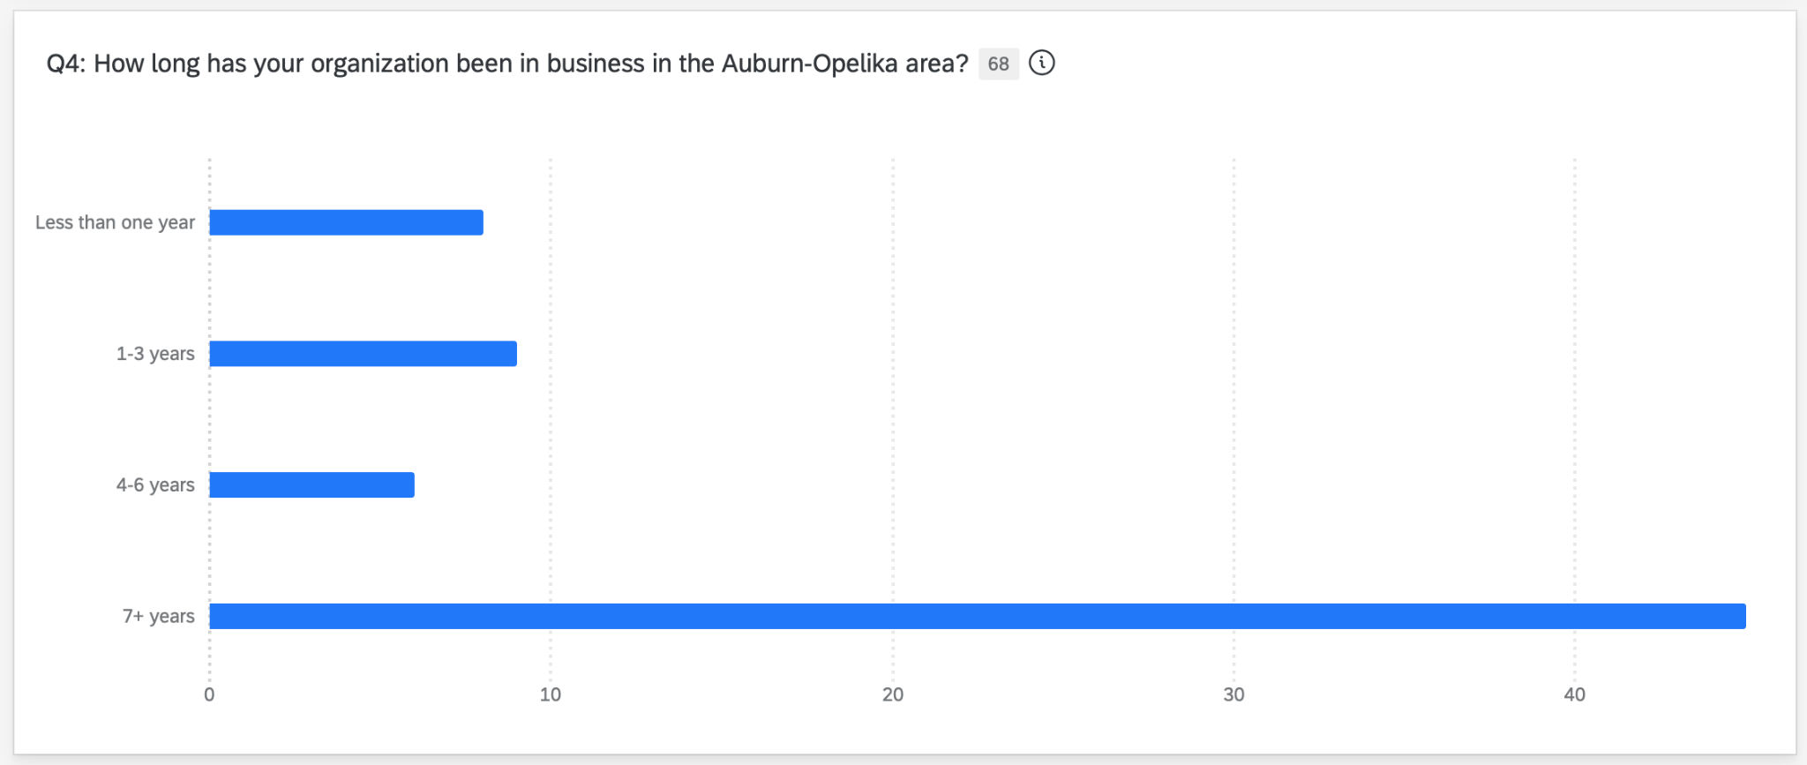
Figure VIII:
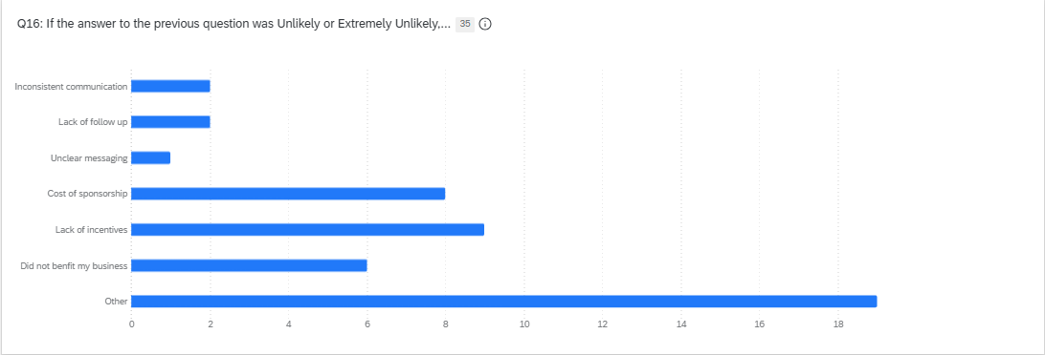
Figure IX:
